Technical Datasheet Input / Output Modules with Modbus RTU Protocol with RS485 Interface

The IO modules communicate via RS485. The port can drive distances up to max 700 meters without the use of any repeater (this feature however also depends on the signal strength of the Modbus Master Device).
The RS485 Digital IO module is sturdy, low power usage and easy to use.

8 Port DI Module:-

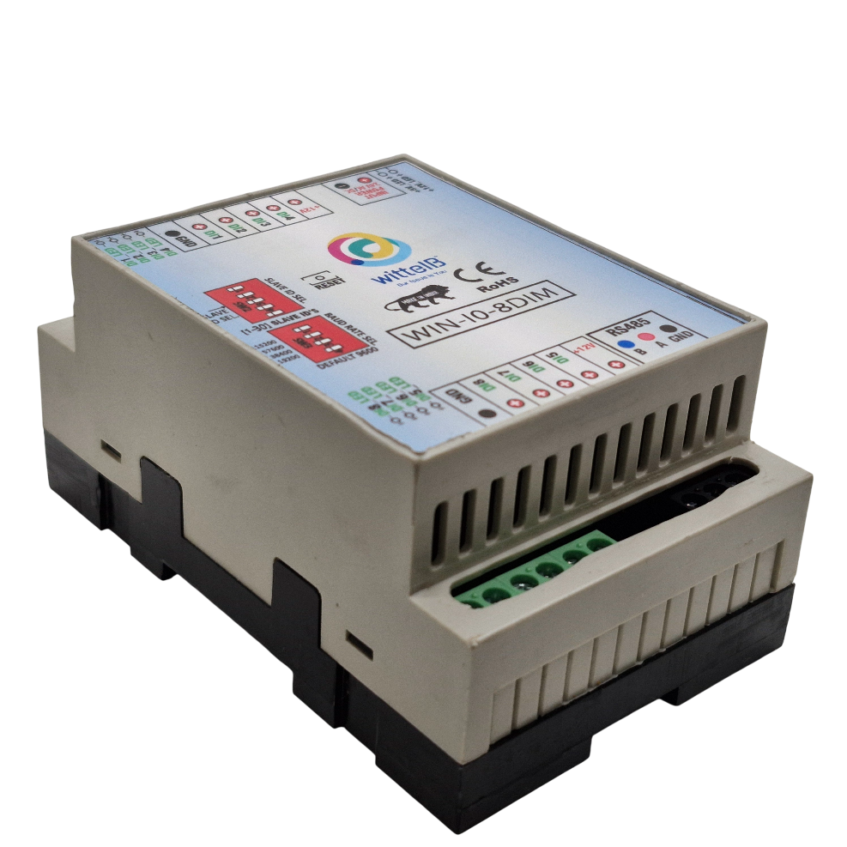

The IO modules are mounted on DIN rail mountable casing and with exposed connectors and LED indicators. The DIP switch for Slave ID and Baud rate are placed inside the enclosure.

The design of the modules incorporates ‘resettable Fuses’ to safeguard against sudden High Voltage spikes. The board also has ‘reverse polarity’ protection both for input Power connector.
The communication port also has signal isolation and additional Jumper for ‘end of line’ 120 ohms termination resistance which may or may not be used.
Specifications
General:-
I/O Connectors 2 Pin 5.08 mm pitch pluggable screw Terminal Block
Dimensions 60 mm L x 110 mm B x 50 mm H
Power Input Power – 12 – 24 VDC or 24 V AC/DC
Typical – 12V DC @ 80mA
Operating Temperature 0 – 60° C (32 ~ 140°F)
Storage Temperature -20 - 70° C (-4 ~ 158°F)
Storage Humidity 5 ~ 95 % RH, non – Condensing
Certifications  

DI Inputs:-
Channels 8
Sense Voltage 3.3 – 30 VDC
Sense Logic Logic ‘0’ = <1 VDC, Logic ‘1’ = >3.3 VDC
Isolation Optically isolated
Response Time 2 msec, Max 6 msec

Additional Features:-
All inputs and communication port isolated
Input power reverse polarity safety
ESD Safety IEC 61000-4-2, ± 30KV contact, ± 30KV air
EFT IEC 61000-4-4, 50A (5/50ms)
750V isolation.
CRC Error check.
No configuration needed on the IO board

DIP SETTING – For Manual Switch Setup
Configuration Settings:-
Communication Speed 9600 – 19200 Kbps (DIP SW selectable)
Data Bits 8
Parity None
CRC Yes
Stop bit 1
Slave ID 1-15 (DIP SW Selectable)
Function code DI 0x02 Read discrete Input
DI Register Address 0,1,2,3,4,5,6,7
ID | Function  Description | Register  Description | Modbus Function Code | Protocol | Data  Type
1 | DI 1(With & Without Potential) | 10001 | 0X02 | RS485 | 1 Bit Boolean
2 | DI 2(With & Without Potential) | 10002 | 0X02 | RS485 | 1 Bit Boolean
3 | DI 3(With & Without Potential) | 10003 | 0X02 | RS485 | 1 Bit Boolean
4 | DI 4(With & Without Potential) | 10004 | 0X02 | RS485 | 1 Bit Boolean
5 | DI 5(With & Without Potential) | 10005 | 0X02 | RS485 | 1 Bit Boolean
6 | DI 6(With & Without Potential) | 10006 | 0X02 | RS485 | 1 Bit Boolean
7 | DI 7(With & Without Potential) | 10007 | 0X02 | RS485 | 1 Bit Boolean
8 | DI 8(With & Without Potential) | 10008 | 0X02 | RS485 | 1 Bit Boolean

Note:-
For MODBUS communications, a shielded and twisted pair cable is used. One example of such cable is Belden 3105A
Recommended Cable Electrical Characteristics: -
22 AWG Cable Shielded and twisted pair
Tinned Copper Recommended
Nominal Conductor DCR 14.7 ohm / 1000 ft
Nominal Capacitance 11 pf / feet (conductor to conductor)
High Frequency Non-Insertion Loss 0.5db / 100ft

BAUD RATE DESCRIPTION:-
MSB
LSB
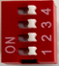
- For Baud rate Selection, DIP SW is used as per the diagram.
- Pulling up the switch will make Baud rate active.
- If no selection is made 9600 will be default Baud rate.
- When u change the Baud rate in the Module power ‘ON’ condition,
pls press the reset button to get Change to affect.
Baud Rate | DIP SWITCH
 | 1 | 2 | 3 | 4
9600 | OFF | OFF | OFF | OFF
19200 | ON | OFF | OFF | OFF
38400 | OFF | ON | OFF | OFF
57600 | OFF | OFF | ON | OFF
115200 | OFF | OFF | OFF | ON

SLAVE ID DESCRIPTION:-

MSB
LSB

- For Slave ID Selection SW is used to Set The SLAVE ID .
- For Slave ID DIP Switch LSB is “1” follow through “4” is MSB.
- Slave ID Confirmed through below Device ID table .
- IF Eg. Slave ID 1 is Needed to be selected Switch number 1 should pulled up other three should be selected down side. So”1 0 0 0” will be selected as Slave ID 1.

Slave ID | DIP SWITCH |  |  |  | OUTPUT (Binary) | OUTPUT (Decimal)
 | 1 | 2 | 3 | 4
0 | OFF(0) | OFF(0) | OFF(0) | OFF(0) | 0 0 0 1 | 1
1 | ON(1) | OFF(0) | OFF(0) | OFF(0) | 0 0 0 1 | 1
2 | OFF(0) | ON(1) | OFF(0) | OFF(0) | 0 0 1 0 | 2
3 | ON(1) | ON(1) | OFF(0) | OFF(0) | 0 0 1 1 | 3
4 | OFF(0) | OFF(0) | ON(1) | OFF(0) | 0 1 0 0 | 4
5 | ON(1) | OFF(0) | ON(1) | OFF(0) | 0 1 0 1 | 5
6 | OFF(0) | ON(1) | ON(1) | OFF(0) | 0 1 1 0 | 6
7 | ON(1) | ON(1) | ON(1) | OFF(0) | 0 1 1 1 | 7
8 | OFF(0) | OFF(0) | OFF(0) | ON(1) | 1 0 0 0 | 8
9 | ON(1) | OFF(0) | OFF(0) | ON(1) | 1 0 0 1 | 9
10 | OFF(0) | ON(1) | OFF(0) | ON(1) | 1 0 1 0 | 10
11 | ON(1) | ON(1) | OFF(0) | ON(1) | 1 0 1 1 | 11
12 | OFF(0) | OFF(0) | ON(1) | ON(1) | 1 1 0 0 | 12
13 | ON(1) | OFF(0) | ON(1) | ON(1) | 1 1 0 1 | 13
14 | OFF(0) | ON(1) | ON(1) | ON(1) | 1 1 1 0 | 14
15 | ON(1) | ON(1) | ON(1) | ON(1) | 1 1 1 1 | 15

SOFT SETTING – For Modbus / Software Setup

Configuration Settings:-
Communication Speed 9600 – 115200 (DIP SW selectable)
Data Bits 8
Parity None
Stop bit 1
CRC Yes
Slave ID Soft settings (1-247).
Function code DI 0x02 Read Discrete Input
DI Register Address 0,1,2,3,4,5,6,7.

Note:-

- In register 40015- you will be able to see the current parity and you can change it in register 40016
- In register 40017- you will be able to see the current stop bit and you can change it in register 40018
- If you want to enter the baud rate 9600/19200/38400/57600/115200etc.
Enter it as 960/1920/5760/11520etc.
- After that press the reset button or reboot the system.
BAUD RATE and SLAVE ID DESCRIPTION:

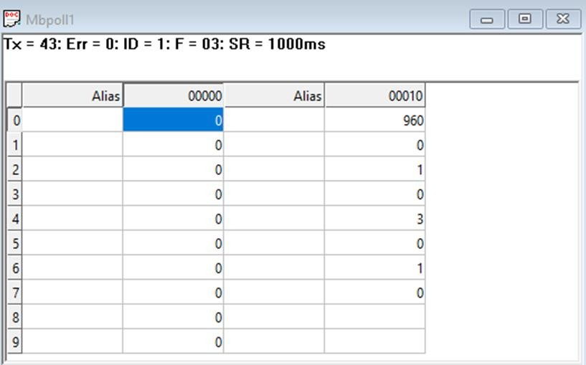

- As you can see in the image above, the resistor 40011 – 960 represents the present bund rate (9600) of the board and 40013 – 1 represents the present slave id of the board.
- To change the baud rate and slave id you have to enter a value on the 40012, resistor for the baud rate and 40014 for the slave id as shown in the image below.

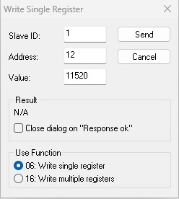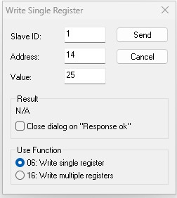

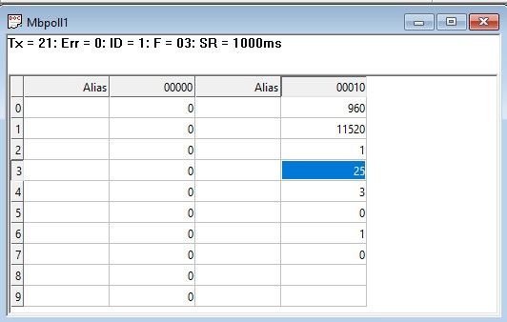

As you can see in the image above I set 115200 baud rate and slave ID 25.
Note:

- When entering baud rate values such as 9600 / 19200 / 38400 / 57600 / 115200, enter them as 960 / 1920 / 3840 / 5760 / 11520, respectively.
- After entering the values, press the reset button or reboot the system.
- Once restarted, you will see the updated values:
- 40011 – 11520 → Baud Rate (115200)
- 40013 – 25 → Slave ID (25)
- You can also change Parity Bit and Stop Bit of the device in the same way.
- Jumper Setting (Hardware Method):
- If you place the jumper, the device will load its default communication settings (default baud rate (9600) and slave ID (1)).
- This is useful when you have many devices with different settings and want a quick way to restore defaults without software changes.
- Relation between Jumper and Reset Button:
The jumper enables the default mode, and the reset button activates it.
- Simply insert the jumper → press reset → the device restarts with factory default settings automatically

DI

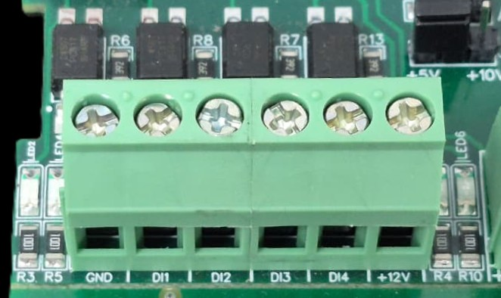
I/p device
I/p device
I/p device
I/p device

- Operation: The module provides four isolated input channels (DI1–DI4) for sensing external signals or dry contacts. These inputs are opto-isolated for circuit protection.
- Terminal Layout:
  - GND: Common Ground reference.
  - DI1 – DI4: Individual Digital Input channels.
  - +12V: Internal reference voltage for sourcing "Dry Contact" switches.
- Wiring Options:
  - Dry Contact: Connect a switch between the +12V terminal and any DI pin.
  - External Voltage: Connect the external signal to a DI pin and the external ground to the GND terminal.
- Voltage Rating: The input circuitry is rated for a maximum of 80VDC. Ensure external signals do not exceed this limit to prevent damage to the isolation ICs.

4 3 2 1
DI +ve Pins
5 6 7 8
DI +ve Pins
Common
GND
Common
GND
Input
12 V DC
Input
12 V DC
Modbus
RS485
Input
12-24 VDC
MSB
MSB
LSB
LSB
Slave ID
Baud Rate

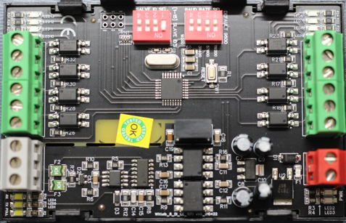

Contact us:-
Augmatic Technologies Pvt. Ltd.,
Plot no 6, Shah Industrial Estate II,
Kotambi,
Vadodara – 391510.
Email – Sales@wittelb.com
Support: support@wittelb.raiseaticket.com / +91 94038 92805

